Data : can be categorized into 2 categories (i) historical (ii) current

1. Historical : we are interested in … that will be useful in analysis,predicting and prescribing
2. Current: that is related to RDMS

#some important key terms used with respect to Historical data

1. Data warehouse:

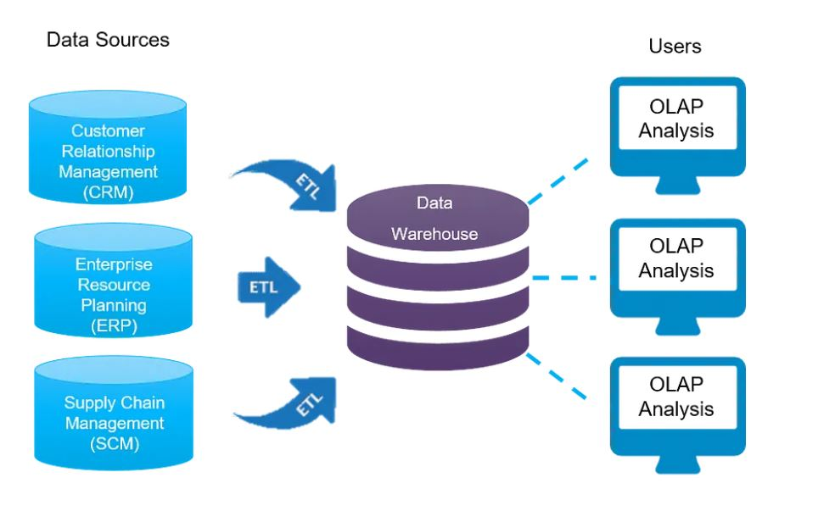

Data warehousing (DW) involves the collection and management of data from various sources to gain valuable insights into a business. A data warehouse serves as a central location for connecting and analyzing different types of business data. It is a key component of a business intelligence (BI) system, enabling data analysis and reporting.

1. Data Mart:

A data mart is a subset of a data warehouse that focuses on a specific department, business unit, or functional area within an organization. It is designed to provide easy access to relevant data for a particular group of users, allowing them to quickly analyze and make informed decisions based on that data.

1. Data Mining:

WHAT HAS HAPPENED???????

Extracting useful data using statistical operation

Data mining is the technique of examining a large data structure to find patterns, trends, hidden insights which would otherwise would not be possible using simpler query based techniques. It uses sophisticated mathematical algorithms to classify, divide, segment the entire data, pre-process it as necessary and evaluate the possibility of future events. *Data Mining is also known as Knowledge Discovery in Data or KDD*

1. Data Analytics:

WHAT WILL HAPPEN???????????????

Past+future

Predict +prescribe

Data analytics is the process of examining data sets in order to find trends and draw conclusions about the information they contain.

|  |  |  |
| --- | --- | --- |
| Aspect | Data Lake | Data Warehouse |
| Data Type | Raw, unstructured, and structured data | Structured data in a schema-on-write format |
| Structure | Schema-on-read | Schema-on-write |
| Purpose | Exploratory data analysis, big data processing, data science | Business intelligence, reporting, decision-making |
| Data Sources | Diverse sources including structured, semi-structured, and unstructured data | Primarily structured transactional data from business applications |
| Processing | Flexibility in data processing and analysis | Optimized for complex querying and analysis of structured data |

What is Business Analytics?

It is a process of transforming data into actions through analysis and insights in the context of organizational decision making and problem solving.

Types of Business Analytics:

1.Descriptive: Descriptive statistics are a set of brief descriptive coefficients that summarize a given data set Key descriptive statistics include measures like mean, median, mode, range, variance, standard deviation, and percentiles

(Hindsight)

2.Diagnostic☹why) Diagnostic analytics refers to the process of examining data to understand the causes of performance outcomes. In the context of business intelligence and data analysis, diagnostic analytics involves using data to determine what has happened and why it has happened.

Tech: Root cause analysis,corelation,regression,drill-down ,visualization,hypothesis testing

3. Predictive:

(Insight) Predictive analytics involves using historical data, statistical algorithms, and machine learning techniques to identify the likelihood of future outcomes based on historical data. It aims to forecast future trends, behaviors, and events by analyzing patterns and relationships within the data.

Key techniques used in predictive analytics include: Regression Analysis,.Time Series Analysis,(used to analyze time-ordered data to make forecasts about future events based on past patterns),Machine Learning Algorithms, Clustering Analysis, Forecasting Techniques(These techniques aim to predict future values based on historical data trends, and may include methods such as moving averages, exponential smoothing, and ARIMA models)

4.Prescriptive:

Identifying best alternative by using optimization to minimize and maximize some objective

Prescriptive analytics focuses on utilizing data and statistical algorithms to recommend actions that can optimize or improve a specific outcome. Unlike predictive analytics, which focuses on forecasting future outcomes, prescriptive analytics goes a step further by providing specific recommendations on how to take advantage of future opportunities or mitigate future risks.

Tech: game theory, recommendation system, optimization, simulation models, decision trees

DATA ANALYTICS LIFE CYCLE:

